After reflecting on others' use of diagrams, I have modified my own, below. Explanations of each process have now been detailed on post-it blocks, as per Gore’s (2024) diagram, to indicate that these are comments, as opposed to function names (UML OMG). The dotted lifelines have also been extended to more clearly show the interactions between the different parts of the system (Object Management Group, 2017). I have also ensured that messages are detailed above each arrow in order to indicate interaction (Object Management Group, 2017).

As suggested by Todorov (2024), I will now include more detail on how the broken authentication attack can be avoided by elaborating on the suggestion that passwords are not stored as plaintext or cleartext, but are instead encrypted (MITRE, 2017). Pillai (2017) suggests the use of hashing to keep passwords secret, utilising strong algorithms such as SHA-1 or SHA-2, with hashes not being re-used across applications. Spraul (2015) advises that user passwords are hashed before being compared to a record of hashed user passwords. However, it is advised that users’ attempts at inputting their passwords are restricted, as even hashed passwords are vulnerable to brute force attacks, with hackers attempting to match pre-compiled hash tables that link hash codes to plaintext passwords (Spraul, 2015). Suggestions to further protect against such attacks involves using multi-factor authentication or applying hash functions more than once (Pillai, 2017; Spraul, 2015). In order to add further complexity to stored, encrypted passwords, Spraul (2015) also discussed the use of ‘salt’ before hashing passwords; here, randomly chosen characters are added to a password before hashing and storing. With this technique, attackers are much less likely to be able to match hash codes to plaintext passwords on a pre-compiled table (Spraul, 2015).

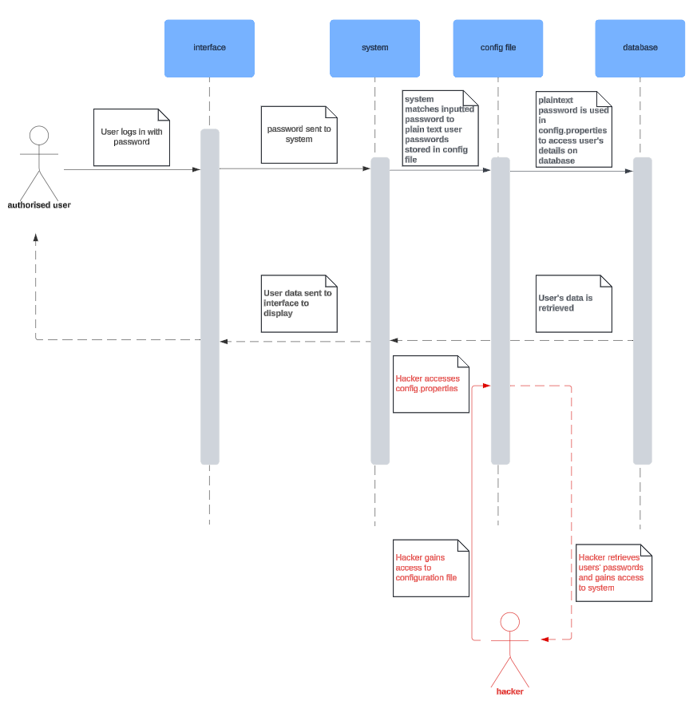

References
MITRE. (2017). CWE VIEW: Weaknesses in OWASP Top Ten (2017). Available at: https://cwe.mitre.org/data/definitions/1026.html [Accessed 10 August 2024].

Object Management Group. (2017) Unified Modeling Language (UML) Specification Version 2.5.1. Available from: https://www.omg.org/spec/UML/2.5.1/PDF [Accessed 5 August 2024].

Pillai, A.B. (2017). Software Architecture with Python. 1st ed. Birmingham: Packt Publishing.

Shraddha, G. (2024) Re: Initial Post. SSD August 2024. Forum post submitted to the University of Essex Online.

Spraul, V.A. (2015). How Software Works: The Magic Behind Encryption, CGI, Search Engines, and Other Everyday Technologies. San Francisco: No Starch Press.

Todorov, H. (2024) Re: Initial Post. SSD August 2024. Forum post submitted to the University of Essex Online.

